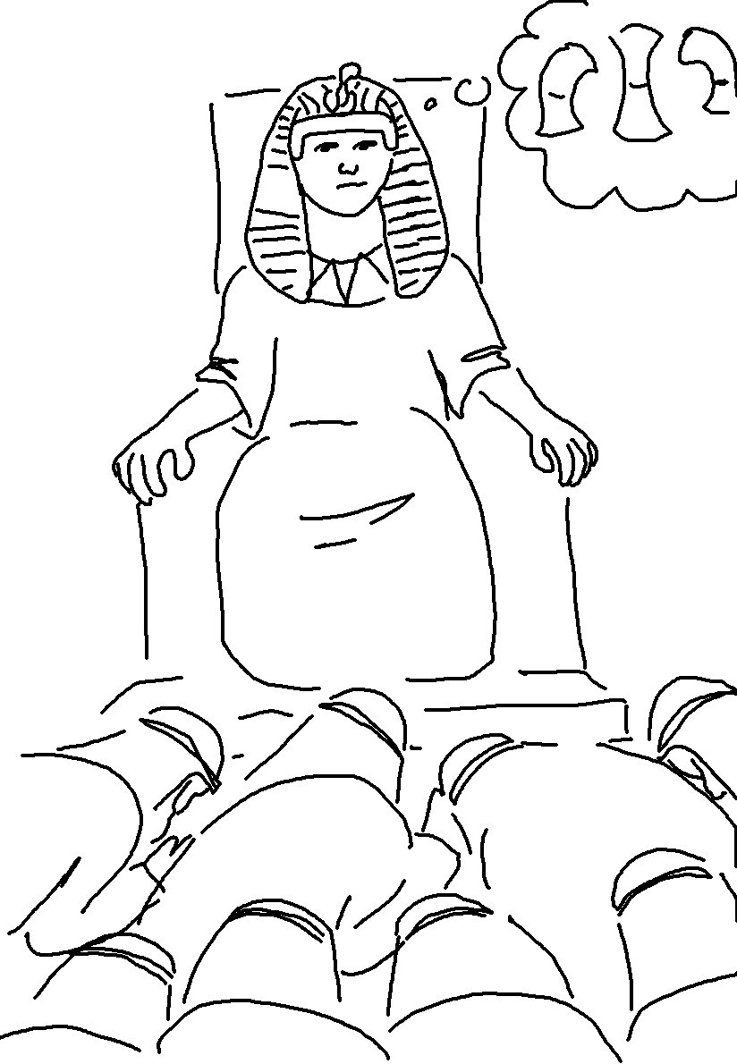
If you are _ _ _ _ _ _ _ _ in little things, you will be faithful in large ones. But if you are _ _ _ _ _ _ _ _ _ in little things, you won’t be honest with greater responsibilities. Luke 16:10_{NLT}

